Ali Albayrak – P304320

Date: 18/08/2017

Assessment Task 1.2 – Binary Search Tree

Test Table:

|  |  |  |
| --- | --- | --- |
| Button | Number | Result |
| Insert | 5 | 5(Leaf) |
| Insert | 10 | 5 - R:10(Leaf) |
| Insert | 2 | 5 – L:2(Leaf) – R:10(Leaf) |
| Insert | 7 | 5 – L:2(Leaf) – R:[10(Leaf)- L:7(Leaf) ] |
| Remove | 5 | 7- L:2(Leaf) – R:10(Leaf) |
| FindMin | - | 2 |
| FindMax | - | 10 |
| Find | 3 | Not Found! |
| Find | 2 | Found! |
| Is Empty | - | No |
| Make Empty | - | Clears everything |
| Is Empty | - | Yes |
| Generate Random | - | Generates 10 random numbers for tree |
| Trace | - | Shows the record of previous and current numbers in the tree. |

Test Table for Error Handling:

|  |  |  |
| --- | --- | --- |
| Button | Number or Entry | Result |
| Insert | X | Message Box “Please enter a number” |
| Remove | X | Message Box “Please enter a number” |
| Find | null | Message Box “Please enter a number” |

Insert Button:

Number 5:

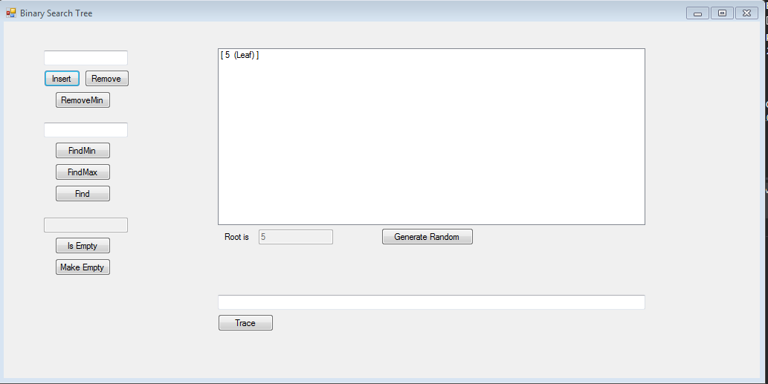

Number 10:

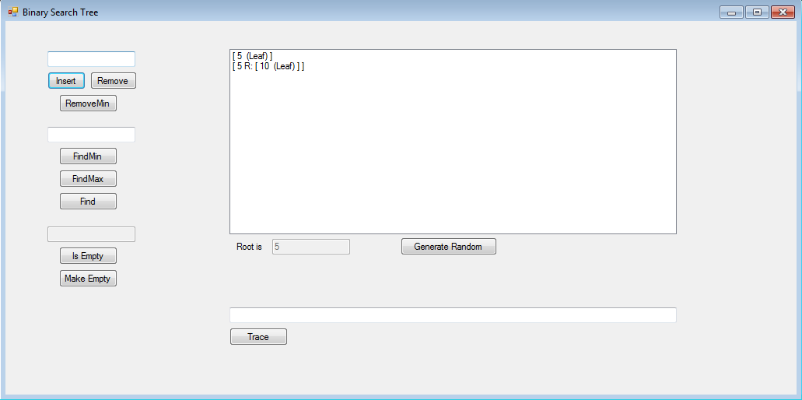

Number 2:

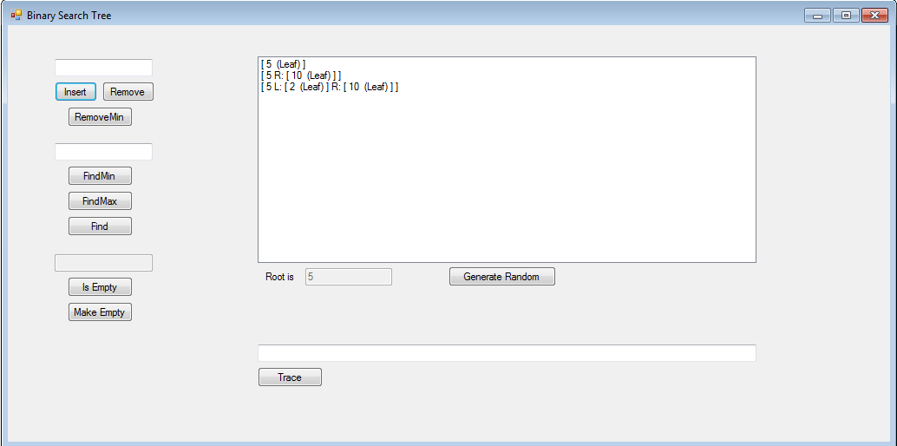

Number 7:

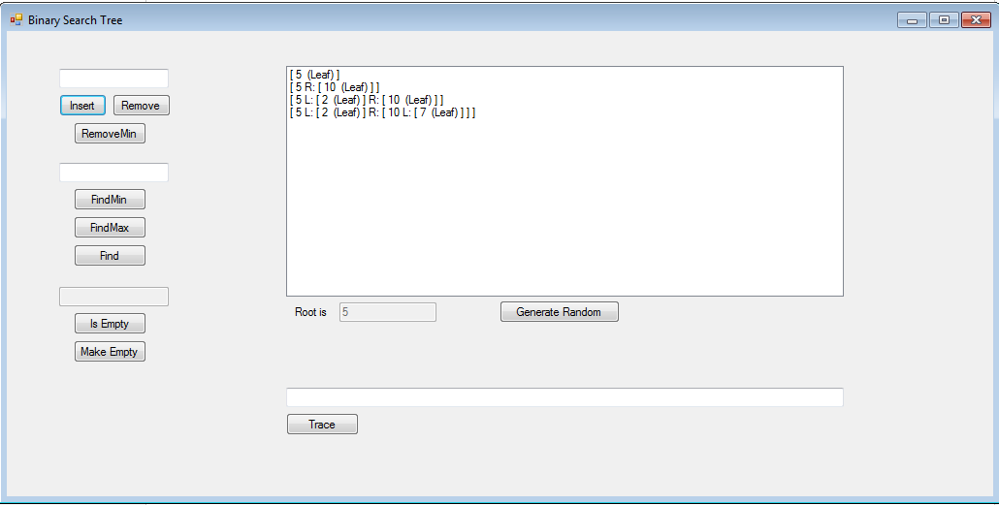

Remove Button:

Remove 5:

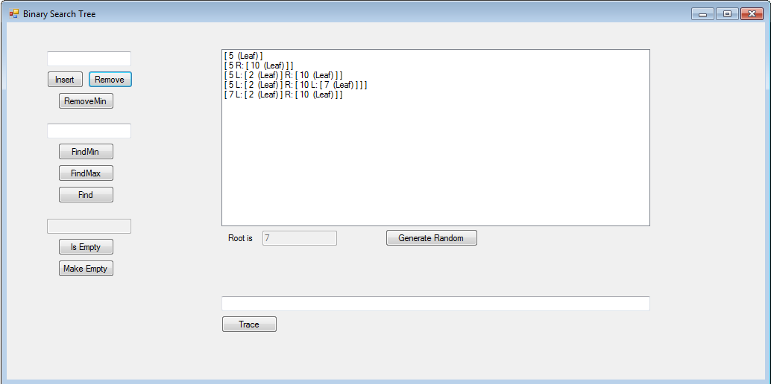

FindMin Button:

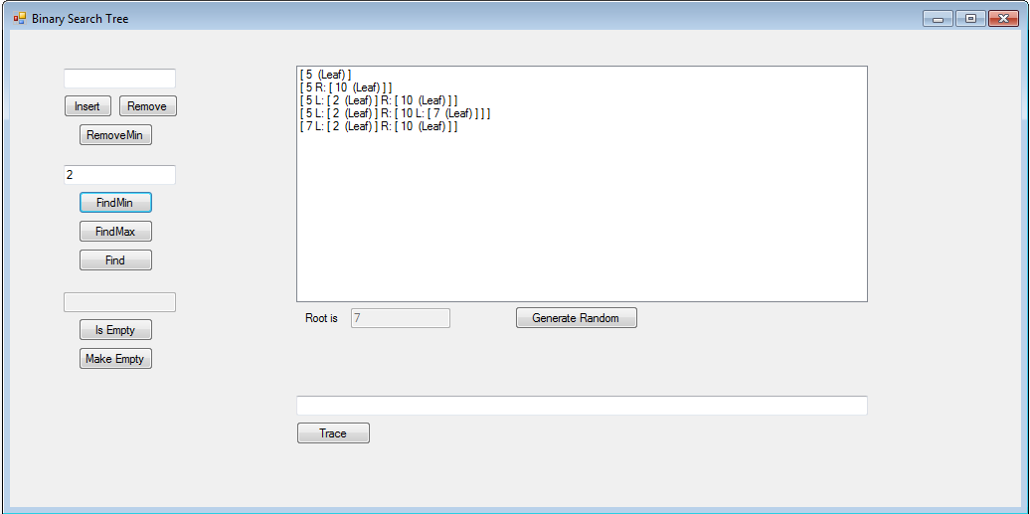

FindMax Button:

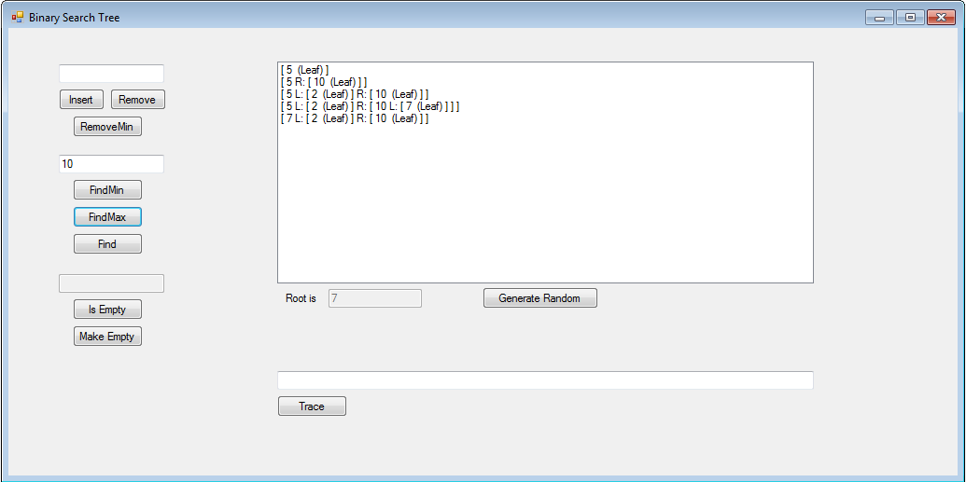

Find Button:

Number 3:

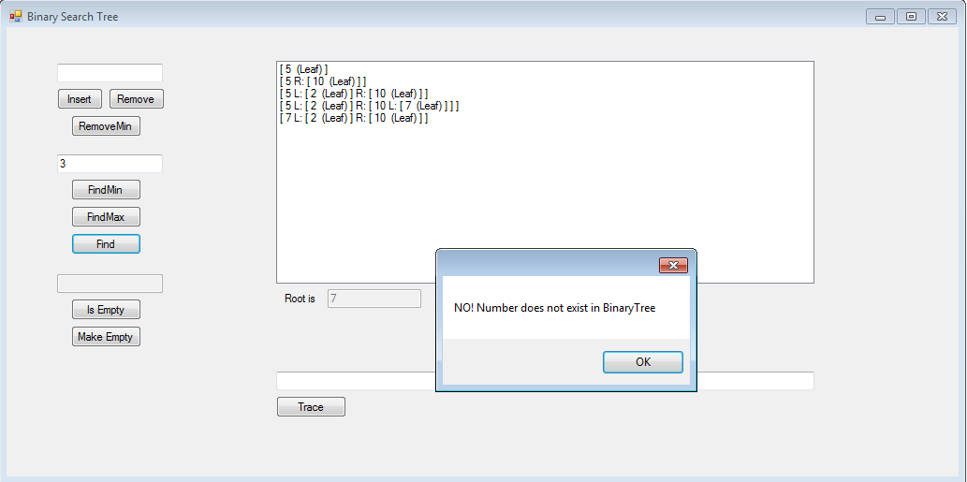

Number 2:

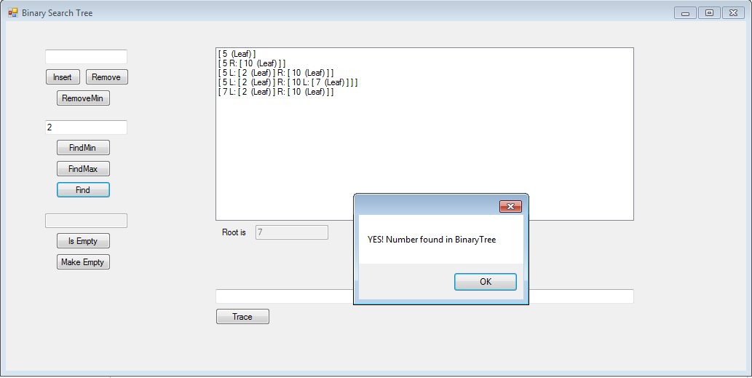

IsEmpty Button:

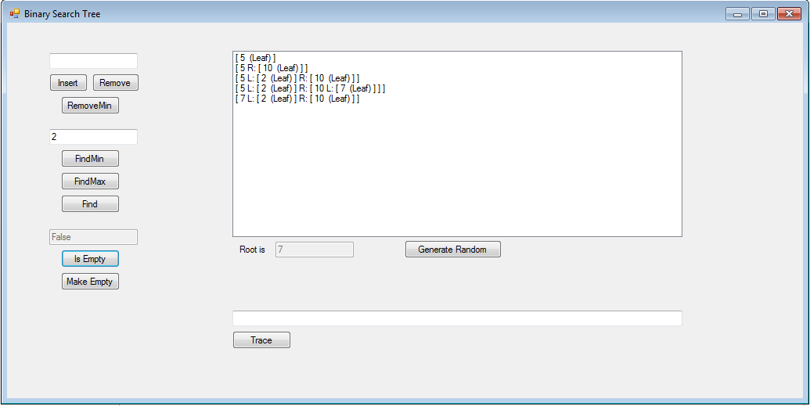

MakeEmpty Button:

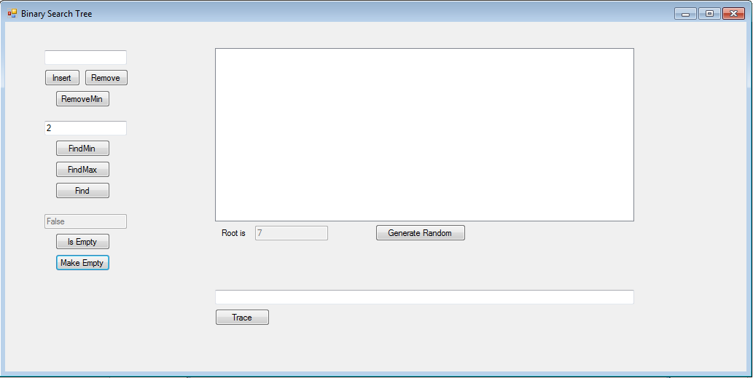

IsEmpty Button(after makeEmpty Button used):

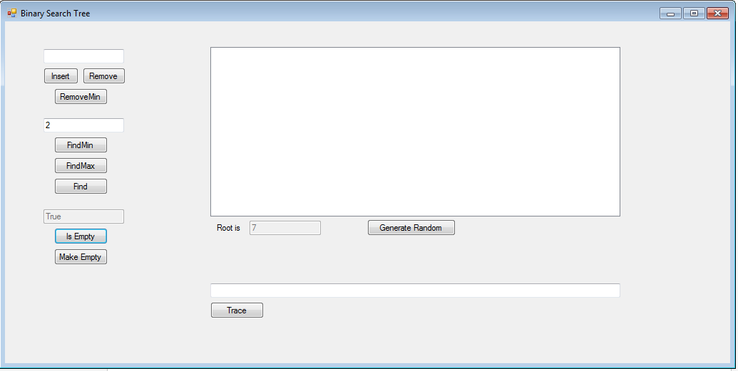

Trace:

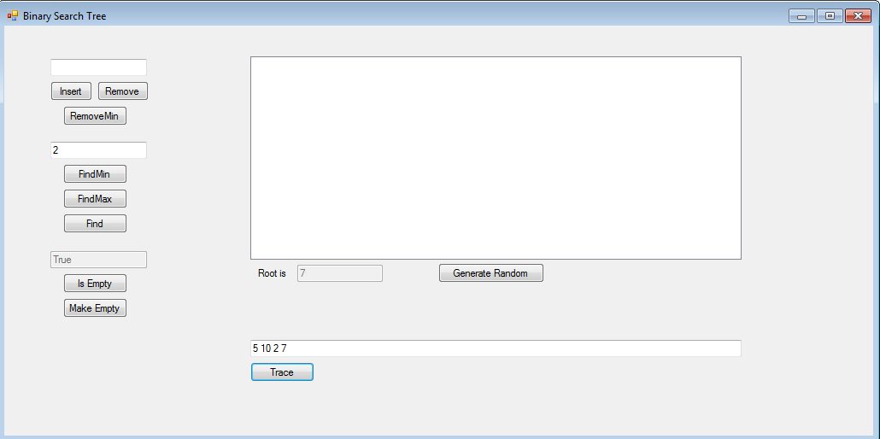

Generate Random Button:

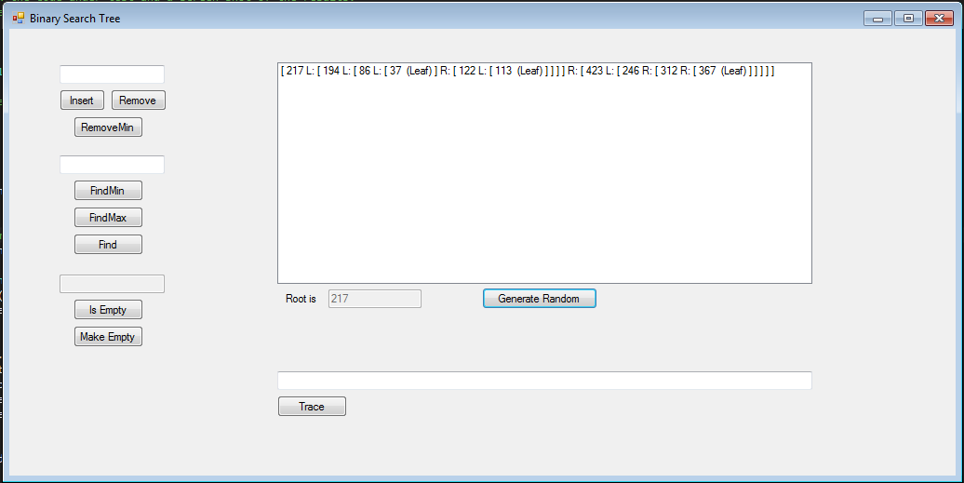

Insert Button(Error Handling):

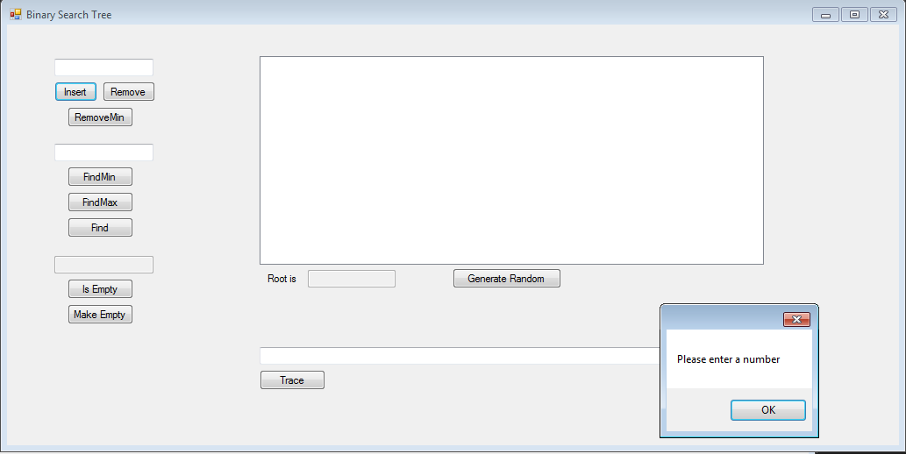

Remove Button (Error Handling):

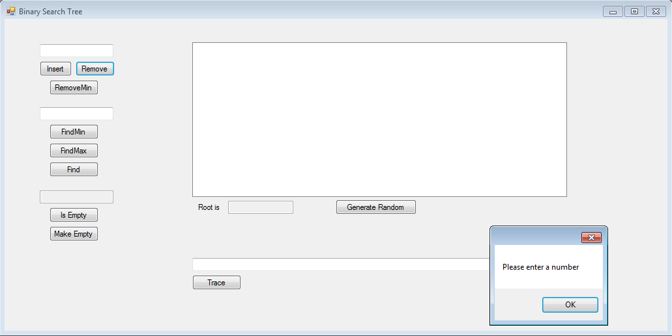

Find Button (Error Handling):

